Theme: FIRE SAFETY AND PROTECTION USING AIML
AUTHOR: NARIND VERMA
Abstract
Urban fire risks are among the most devastating of threats to human life and infrastructure resilience. The risk is enhanced in modern cities by high population density, the vertically growing building profile, and complex architectural structures that have a tendency to create choke points during evacuation. Traditional fire protection systems–dependent mostly on alarms, sprinklers, and static signage for evacuation–are imperative but insufficient. These systems are not real-time adaptable, provide little situational awareness, and have a tendency to depend heavily on man's judgment, which panics and fails when under stress. As a result, even when threats are detected early, evacuations at large scale turn chaotic, delayed, or fatally clogged.
This research bridges these gaps by proposing a general fire safety and evacuation system that integrates Artificial Intelligence (AI), Machine Learning (ML), and Internet of Things (IoT) technologies into an inference-based decision-support system in real time. In its core form, the framework combines a number of layers: (i) smoke, heat, and toxic gas sensor-based fire detection at the level of IoT devices; (ii) classification models driven by ML based on historical fire event data to reduce false alarms and allow predictive warnings; (iii) a multi-criteria decision engine for evacuation based on TOPSIS[1] to determine the best evacuation paths while considering safety, travel time, and congestion risk; and (iv) graph coloring algorithms[2] employed for evacuation via network-based building plans, so that non-overlapping evacuation paths are guaranteed for different sets of occupants in order to prevent bottlenecks. The design of the system is focused on not just guiding evacuees with an adaptive routing mobile application but also providing a continuous flow of information to emergency responders in order to assist synchronized fire suppression measures. This approach, when compared to conventional fire protection systems, puts emphasis on flexibility, data-driven decision-making, and scalability.
The article also provides pseudocode for the TOPSIS[1] and graph coloring algorithms[2], which outline their potential execution in real-world building safety systems. By bringing together IoT sensing and AIML-based decision-making, the study seeks to demonstrate how evacuation from a building may be revolutionized from a reactive, one-size-fits-all process into an individualized, dynamic, and congestion-free process of evacuation. The framework has the potential to redefine fire safety regulations for public buildings and serve as a template for designing smarter and more resilient future infrastructure.
Keywords
Fire safety, Artificial Intelligence, Machine Learning, IoT sensors, TOPSIS, Graph coloring, Evacuation routing, Decision support systems, Building resilience, Real-time navigation
1. Introduction
1.1 Background and Motivation
Fire accidents are some of the most catastrophic risks which threaten human lives, assets, and economic stability. Fire accidents cause almost 18,000 human fatalities each year, and they are largely taking place in heavily populated cities where evacuation becomes very hard. Globally, fire burn accidents are estimated by the World Health Organization (WHO) to be a leading cause of accidental deaths annually, and hence intelligent fire protection systems are a priority. Despite the high-profile progress toward fire-resistant building codes, sprinklers, and automated alarm systems, these traditional devices are still detection based, not responsive.
During a fire, there is little time to get out alive, generally not more than a few minutes in the best of cases, and hence smart and quick thinking is an absolute necessity. Modern-day buildings are becoming taller, larger, and more complicated with shopping malls, airports, hospitals, and schools accommodating hundreds, even thousands, of individuals at any given point in time. In these type of situatiions evacuation congestion, deceptive signs, and crowd hysteria most often lead to stampedes or getting trapped inside. There are some incidents that has occurred in the past including the 1997 Delhi Uphaar Cinema complex fire and the 2017 London Grenfell Tower residential high-rise apartment building fire. The stud on these tragedies aims to promote the urgent need for sophisticated fire protection systems that are beyond passive alarm and the use of live intelligence this can be done by a customized system that aims to leverage these limitations and build a proper system to tackle all these
1.2 Limitations of Conventional Fire Protection Systems
The conventional fire protection systems consist of four major components: heat/smoke detectors, sprinkler systems, alarm devices, and fixed means of escape provided in the form of signage. Useful as they might be to smother hotfire spread in the initial stages and warn the occupants, they fall short in a number of key areas
1. Preplanned Evacuation: Identification and exit are specified in terms of fire location, smoke pattern, or population distribution. Unaware, individuals move toward hazard areas.
2. Dependence on Human Judgment: Panic distorts sound judgment during crisis. Lacking real-time instructions, individuals move toward familiar doors, causing congestion.
3. Co-ordinated Delayed Response: Fire brigades are manually communicated and hence are prone to receive obsolete or incomplete information about hazard location and crowd movements.
4. No Predictive Capacity: The available systems can alarm but do not have predictive capability to forecast hazard development and simulate under different conditions.
These limitations point out the distinction between alarm-driven fire detection and adaptive, actionable evacuation protocols. Alarm systems warn the occupants of risks but don't inform individuals how to evacuate most effectively in constantly evolving situations.
1.3 The Potential of Artificial Intelligence and IoT
There has been many developments in the fields of AI/ML and IOT that give many possibilities to transform fire safety. IoT sensors can be used to monitor environmental changes like the smoke density, CO2 levels , temperature changes and human traffic regularly on given intervals. These real-time streams of data, when analyzed by ML algorithms, can allow:
•Early Fire Detection: Historical fire data-trainable ML classifiers can identify true fire threats from false alarms (e.g., cooking vapor, steam).
•Dynamic Evacuation Planning: Computation of optimal evacuation routes that evolve with fire spread, building condition, and congestion can be performed by algorithms.
•Decision Support: Multi-criteria decision models such as TOPSIS[1] (Hwang & Yoon, 1981) can rank evacuation options based on safety, proximity, and crowd flow efficiency.
• Congestion Management: Graph algorithms[2], specifically graph coloring, enable assignment of unique evacuation routes to unique groups of occupants in a way that prevents bottlenecks.
• Integration with Fire Departments: The data can be transmitted in real time to responders for the purpose of coordination and resource allocation.
AI and IoT as a pair represent a feedback process whereby detection, analysis, and action take place in near real time.
1.4 Problem Statement
In spite of advances in smart safety systems, there is not yet an integrated end-to-end system that brings together fire detection, adaptive evacuation, and real-time coordination. All solutions today are silos—detection sensors trigger occupants, but evacuation is still a function of human judgment; simulation models simulate evacuation in the design phase but are not applied in real-time response. Not filling the huge gap with intelligent, dynamic evacuation planning still remains the great void.
This work resolves the issue by suggesting an IoT-based, AI/ML-powered fire protection system that incorporates detection, decision-making, and evacuation assistance. Employing multi-criteria decision-making with TOPSIS[1]and graph coloring[2] for conflict-free routing, the framework makes evacuation plans adapt dynamically to varying hazards.
1.5 Research Objectives
The key objectives of this research are:
1.Creating an IoT-based sensor network for real-time fire detection.
2. For the application of ML algorithms for fire danger classification and false alarm minimization.
3. To rank and analyze evacuation routes using the TOPSIS[1] approach based on safety, time, and congestion factors.
4. For maximizing evacuation by graph coloring to provide distinct, non-intersecting routes to sets of occupants.
5. For integrating the decision engine into a mobile app that steers the occupants dynamically as well as notifies the emergency responders.
1.6 Contribution of This Work
This work makes the following contributions to fire safety and smart infrastructure:
•Creating a multi-layered framework that integrates IoT sensing, ML detection, and decision-making.
•Suggesting pseudocode algorithms for TOPSIS[1], graph coloring[2], and ML classifiers for real-world application.
•Proposing a mobile-based navigation screen for real-time guiding of occupants.
•Proposing a scalable system that can be customized for various types of public buildings.
1.7 Paper Organization
The rest of the paper will proceed as follows.
Section 2 covers existing work on IoT-based fire detection, AI/ML in safety systems, and graph theory-based evacuation models. Section 3 explains the proposed method in minute detail. Section 4 explains the system architecture in minute detail, describing its layering. Section 5 presents pseudocode and algorithmic description of TOPSIS[1], graph coloring[2], and ML classifiers. Section 6 lays down expected outcomes and advantages. Lastly, Section 6 concludes the research and identifies possible directions of future research.

2. Literature Review
2.1 IoT-Based Fire Detection
The Internet of Things (IoT) has revolutionized building safety such that sensors function as a distributed nervous system that tracks environmental conditions around the clock. Conventional fire detectors use single-point initiators like smoke or heat. These do not work in giant, multi-storey buildings where fires can initiate in secluded spaces. IoT allows for sensor networks to collect data from smoke, carbon monoxide, CO₂, temperature, and humidity sensors at once. Hsiao and Hsieh (2023)[4] showed a real-time fire protection architecture with IoT nodes coupled with cloud analytics. The paper showcases how persistent sensing can enhance the accuracy of hazard localization and mitigate response latency. Further, high-end communication protocols (LoRaWAN, ZigBee, Wi-Fi 6) ensure sensor networks are resilient to node failure during disasters. Edge computing has also been utilized, which enables preprocessing close to the sensor in order to reduce transmission latency.
2.2 AI and ML in Fire Safety and Early Warning
IoT sensor data streams need to be converted into useful intelligence. Artificial Intelligence (AI) and Machine Learning (ML) help do this by understanding patterns in sensor data. Traditional systems tend to generate alarms based on false alarms like burnt cuisine or welding sparks. ML classifiers—Random Forests, XGBoost, and neural nets—have learned on historical data sets to identify real fires from harmless situations. Modern works employ Convolutional Neural Networks (CNNs) for detecting flames and smoke from CCTV streams. Recurrent Neural Networks (RNNs) and Long Short-Term Memory (LSTM) networks forecast the advancement of fire over time from time-series sensor information. Ensemble learning enhances robustness by aggregating the predictions of many models. All these methods lower false alarms and missed detections significantly.
2.3 Evacuation Modeling and Human Behavior
Efficient evacuation is not merely reliant on fire detection but on human action in emergency situations. Investigations into pedestrian dynamics show that people tend to prefer familiar routes over optimal ones, resulting in bottlenecks. Classical models of evacuation like Cellular Automata, Social Force Models, and Agent-Based Simulations try to model crowd behavior in panic situations. But they are largely design-time models and never become dynamic to change according to real-time data. Research indicates adaptive evacuation guidance cuts down casualties by as much as 30% in simulation tests. By incorporating such models with real-time IoT sensor data, dynamic updates can be made to evacuation plans, considering crowd pressure, smoke spreading, and obstructed routes.
2.4 Multi-Criteria Decision Making in Safety Systems
Evacuation routing is a multi-criteria problem by nature: routes should trade off travel time, safety (fire proximity), and congestion hazard. Multi-Criteria Decision-Making (MCDM) methods have found applications in disaster management. Of them, TOPSIS[1] (Technique for Order Preference by Similarity to Ideal Solution) is most well-known. TOPSIS[1], developed by Hwang and Yoon (1981), orders alternatives according to their geometric proximity to an ideal solution. In fire evacuation, each feasible route can be compared against such criteria as distance, hazard exposure, and occupant load. TOPSIS[1] offers a systematic decision mechanism that adjusts as environment changes.
2.5 Applications of Graph Theory to Evacuation Routing
Buildings can be graphically modeled as a graph with room and corridor nodes and connection or door edges. Graph algorithms are well-suited to path planning with changing constraints. Graph coloring specifically guarantees that multiple groups of evacuees get distinct, non-overlapping paths, which reduces congestion. Studies in network-based evacuation indicated that the use of colored path assignment greatly minimizes evacuation time in high-density cases like stadiums or airports. Through the combination of graph coloring and IoT information, the paths can dynamically be reassigned with changes in conditions. This promotes both safety and efficiency, and as such, graph theory forms a key part of adaptive evacuation planning.
3. Proposed Methodology
The system proposed uses IoT sensors, ML-based hazard classification, TOPSIS[1]-based decision support, and congestion-free routing by graph coloring[2], and these are made available through a mobile app.
________________________________________
3.1 IoT Sensor Network
The system relies on a sound network of sensors that are constantly taking readings of environmental conditions within the building. Modern IoT technology provides the ability to utilize heterogeneous sensors including smoke detectors, heat probes, CO and CO₂ detectors, flame detectors, and IR thermal imagers. Each of these sensors is used to compensate for specific weaknesses of traditional fire alarms that rely on single-mode detection. For example, smoke detectors may ring false alarms from cooking fumes, while heat sensors will most probably respond too late in large open halls. Through integration of diverse inputs, IoT network supports greater accuracy and reliability.
The sensors communicate with each other wirelessly through protocols like LoRaWAN or ZigBee, chosen due to their low power usage and mesh networking capabilities. Even when portions of the network are burnt out by fire, communication is possible. Data is fed into edge gateways, where preliminary filtering is completed. For instance, if a single smoke detector registers suspicious levels but not those in the immediate vicinity, the edge node can flag the reading as suspicious rather than triggering it immediately. Preprocessing of this kind reduces false positives and conserves bandwidth for critical warnings.
Additionally, IoT sensors are strategically located by the Building Information Model (BIM)[3] for optimal coverage. Special areas such as kitchens, electrical rooms, and commodity stores containing flammable material are prioritized. Occupant density sensors (Bluetooth signal-based or passive infrared) are also present, enabling the system to monitor where individuals are gathering in real time. Together, this network of sensors forms the system's nervous system, gathering rich streams of data that power the AI/ML classification module.
________________________________________
3.2 Machine Learning Fire Classification
The vast quantity of sensor data necessitates intelligent classification mechanisms. The system uses Machine Learning (ML) classifiers, trained on historical fire datasets, augmented with controlled experimental simulated data. A Random Forest algorithm is used for initial deployment as it is interpretable, noise tolerant, and heterogeneous feature capable of handling.
The classifier takes inputs such as smoke particle density, rate of temperature increase, CO₂ concentration, and visual flame from CCTV footage. Every feature captures a different aspect of fire growth. A sharp temperature spike with falling visibility from smoke detectors for example is characteristic of combustion, but slow temperature rise with no smoke may signify innocuous heating. The classifier is taught to detect these subtle signs, reducing both false alarms and false dismissals.
In addition, ensemble methods involving Random Forests with gradient boost algorithms (e.g., XGBoost) can be utilized to further enhance accuracy. Models are retrained continuously using online learning to accommodate building-specific conditions such as HVAC airflow patterns that may impact smoke diffusion. The ML component attains context-specific information regarding each building environment over time, thereby becoming more reliable than conventional detectors.
____________________________________
3.3 TOPSIS for Route Ranking
Once a fire is verified, the focus of the system is on evacuation planning. Evacuation routes are considered options in a multi-objective decision problem with conflicting goals where multiple criteria must be traded off. TOPSIS[1] is employed as it can accommodate conflicting objectives.
The three primary criteria under consideration are:
1. Safety – Travel distance from fire zones or smoke dispersion.
2. Walking time – Route distance relative to walking speed and possible obstacles.
3. Risk of congestion – Number of passengers currently assigned to the route.
Weights for individual criteria may be adjusted based on context. For example, safety would be prioritized over speed at a hospital but not in a stadium where preventing congestion could be prioritized more. TOPSIS[1] normalizes the decision matrix, applies weights, and computes closeness values for each possible route. Routes with higher closeness values are ranked as more preferable.
This is executed continuously, not once. When sensors detect changes—such as smoke filling a corridor—decision matrix is updated and TOPSIS[1] re-calculates rankings. This implies that evacuation instructions are dynamic, adapting to the changing hazard and not to static evacuation charts.
____________________________________
3.4 Graph Coloring for Congestion Avoidance
Although TOPSIS[1] is used to provide optimal routes, assigning the same route to all occupants may result in bottlenecks. To avoid this, the system employs graph coloring algorithms.The buildings will be shown as a graph, in which corridors and rooms are nodes and walkways will be edges. The occupents will be classifies according to the physical location they are on and each category will be assigned a color denoting a distinct evacuation route.
Graph colouring will ensure that adjacent clusters that are likely to bunch up in corridors are assigned distinct pathways avoiding potential clash or overlap in them.For example people on the same floor but different sides of a building can be directed to distinct staicases even when one staircase is more quicker this can avoid clash in the human traffic and can minimize the evacuation time marginally.
This methods changes the evacuation from a sort of optimization problem to an cooperative solution where routes are synchorinized to maximize overall safety. Computational experiments on simulating crowd behavior have shown coordinated routing can reduce evacuation time by up to 25–30% over uncoordinated movement.
_____________________________________
3.5 Mobile Application Interface
The final component of the system is a smartphone application that delivers evacuation directions to users. The application serves as the human–machine interface, translating algorithmic choices into easy-to-follow instructions. Users receive turn-by-turn guidance like GPS directions, complemented by visual and audio aids leading them to the closest safe exit.
In contrast to fixed-point evacuation signage, the app reacts in real-time. If a prescribed path is interrupted by unplanned fire spread, the app re-calculates and updates directions simultaneously. Staggered movement is also encouraged to occupants where congestion is predicted. To assist accessibility, the app is multi-lingual voice command accessible and may also be paired with wearable devices for haptic alerting, aiding individuals with visual or hearing impairments.
At the same time, the application gathers anonymized coordinates and transmits them to the fire dispatch center. This provides emergency responders with a real-time situation map of fire progression, occupant positions, and routing allocations. Such awareness of the situation enables fire brigades to lead rescue operations into danger zones rather than spend valuable time looking for individuals.
The system is also employed as a training aid. In regular fire drills, dummy information can be fed into the system so that the occupants can practice complying with shifting commands. Over time, this instills familiarity and damps down panic in actual emergencies.
4. System Architecture
The architecture is layered:
1.Sensing Layer: Data are gathered by IoT sensors.
2.Edge Layer: Gateways filter and preprocess signals.
3.Decision Layer: ML classifiers identify fire hazards.
5.Application Layer: Mobile app guides occupants; Dashboards are sent to fire departments for monitoring.
The modular structure provides scalability and fault tolerance.
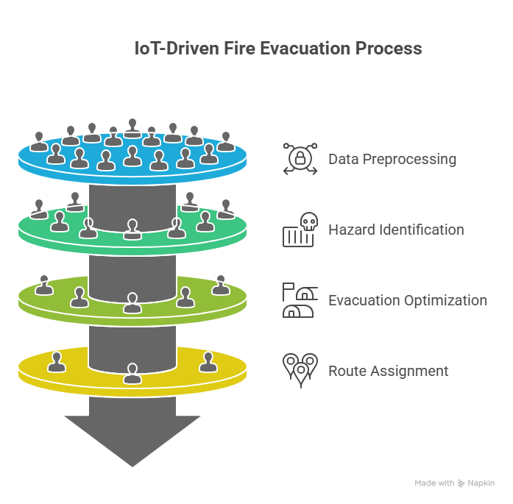VISUAL REPRESENTATION OF THE SYSTEM ARCHITECTURE
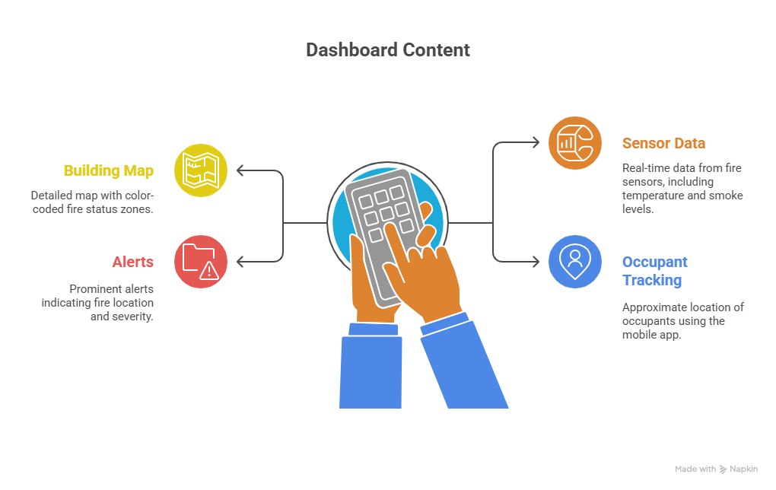
REPRESENTATION OF THE MOBILE APP THAT WILL GUIDE OCCUPANT
5. Algorithms
5.1 FlowChart for TOPSIS
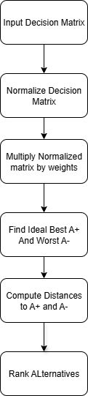
Input: Decision matrix D with alternatives (routes) and criteria (safety, time, congestion)
Output: Ranked list of routes
- Input Decision Matrix (alternatives × criteria).
- Normalize Decision Matrix (vector normalization).
- Weight Normalized Matrix (multiply by criteria weights).
- Determine Ideal Best (A⁺) and Ideal Worst (A⁻) Solutions
  - A⁺: best value for each criterion.
  - A⁻: worst value for each criterion.
- Calculate Separation Measures
- Distance of each alternative from A⁺.
- Distance of each alternative from A⁻.
- Compute Relative Closeness (Ci)
$$Ci​=\frac{{Si}^{-}}{\left({Si}^{-}-​{Si}^{+}\right)​​}$$
- Rank Alternatives (higher Ci = better rank).
Explaination of the TOPSIS algorithm
The TOPSIS[1] algorithm {TECHNIQUE FOR ORDER PREFERENCE BY SIMILARITY TO IDEAL SOLUTION } is a multi criteria decision making technique which is used to select the best choice among a set of options when multiple options are conflicting.
The fundamental principle of TOPSIS[1] is that the chosen alternative should have:
- The shortest distance from the ideal best solution (A⁺), and
- The farthest distance from the ideal worst solution (A⁻).
This ensures that the selected outcome is close to the most desirable outcome and also away from the least desirable one.
Decision Matrix
- Suppose there are mmm alternatives and n criteria.
- The decision matrix is represented as:
$$X=\left[xij​\right]where i=1,2,…,m and j=1,2,…,n$$
In the above scenario xij represents the performance score of the ith alternative with respect to the jth criteria
Vector Normalization
Owing to the fact that criteria could be in various units (e.g., cost in dollars, speed in Mbps, time in hours), comparison is not feasible. Vector normalization is used to resolve this by converting the decision matrix into a dimensionless one.
The normalized value is computed as:
$rij​=xij/√(\sum_{i=1}^{m}{xij^2)}$
- All the normalized values an in the range [0,1] and can be compared across featues.
Weighted Normalized Matrix
To find the most important criteria or the importance of different criteria each normalized value is multiplied by the weight wj such that.
$$vij​=wj​⋅rij​,\sum_{j=1}^{n}{​wj​=1}​$$
This step is used to ensure that the most important criteria/feature influences the decion more strongly.
Ideal Best (A⁺) and Ideal Worst (A⁻)
- Benefit criteria (higher is better):
$${Aj}^{+}​=max\left(vij​\right),{Aj}^{-}​=min\left(vij​\right)$$
- Cost criteria (lower is better):
$${Aj}^{+}=\min\left(vij\right), {Aj}^{-}=max\left(vij\right)$$
In conclusion A+ represents the most favourable values across all the features and A- represents the lease favourable ones.
Separation Measures
For each alternative, calculate the Euclidean distance from the ideal best and worst:
$${Si}^{+}=\sqrt{\sum_{j=1}^{n}{{\left(vij- {Aj}^{+}\right)}^{2}}}$$
$${Si}^{-}=\sqrt{\sum_{j=1}^{n}{{\left(vij- {Aj}^{-}\right)}^{2}}}$$
Relative Closeness
We find the closeness of each alternative to the ideal solution which can be computed by the given formula:
$$Ci​=\frac{{Si}^{-}}{\left({Si}^{-}-​{Si}^{+}\right)​​}$$

- If Ci​ is closer to 1, the alternative is better.
- If Ci​ is closer to 0, the alternative is worse.

Ranking
Finally, all alternatives are ranked in descending order of Ci​. The one with the highest closeness coefficient is chosen as the best alternative.
Code Implementation of TOPSIS:
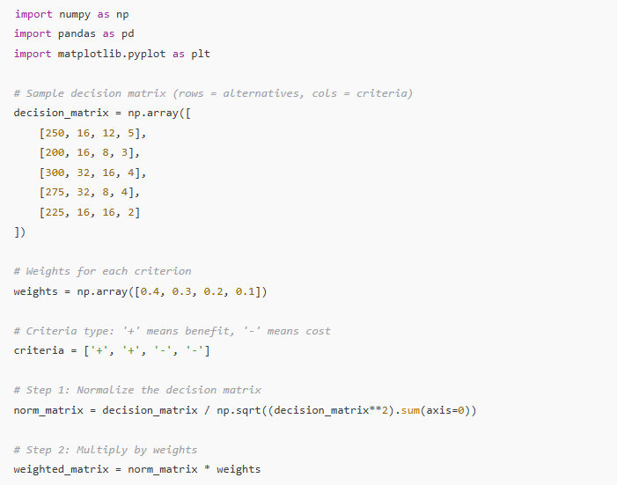
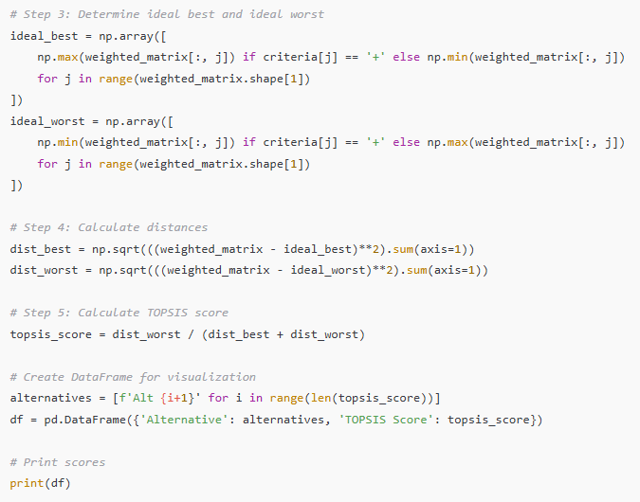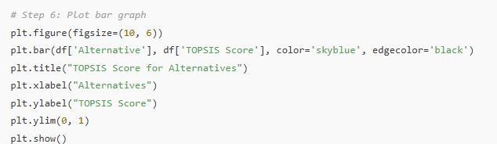

OUTPUT OF THE CODE:
Alternative TOPSIS Score
0 Alt 1 0.297593
1 Alt 2 0.349046
2 Alt 3 0.650954
3 Alt 4 0.801402
4 Alt 5 0.250814
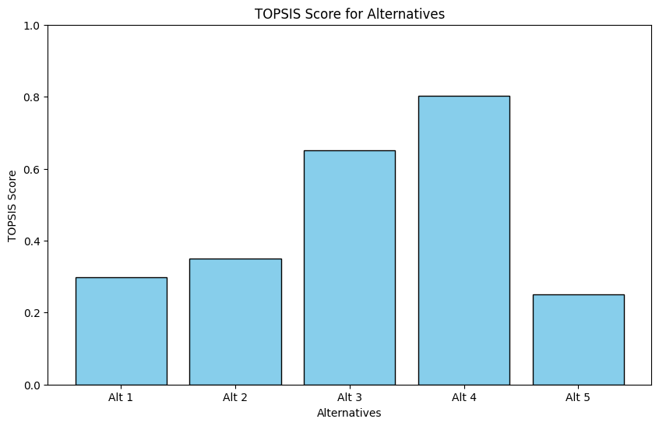
THIS OUTPUT RANKS THE ALTERNATIVES BASED ON THE TOPSIS ALGORITHM.
GRAPH COLORING ALGORITHM:
Input: Graph G(V,E) representing building layout
Output: Cluster-wise non-overlapping evacuation routes
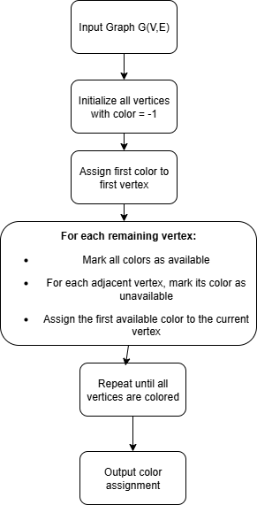
Algorithm GraphColoring(Graph G(V, E)):
1. For every vertex v in V:
color[v] ← -1 // -1 indicates no color set yet
2. color[first vertex] ← 0 // color the first vertex with first color
3. For each vertex u in V starting from second vertex:
Initialize available[] ← True for all colors
For each adjacent vertex w of u:
If color[w] ≠ -1:
available[color[w]] ← False // set color as unavailable
Find the first color c where available[c] = True
color[u] ← c
4. Return color[]
CODE FOR GRAPH COLORING
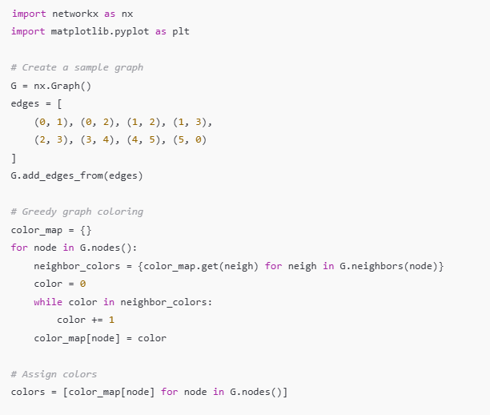
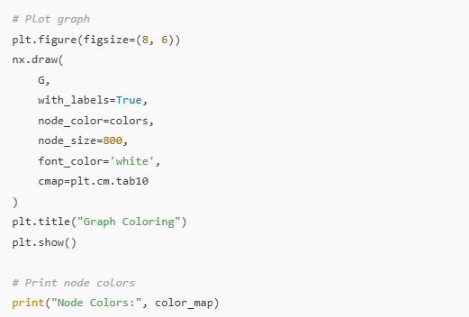
OUTPUT:
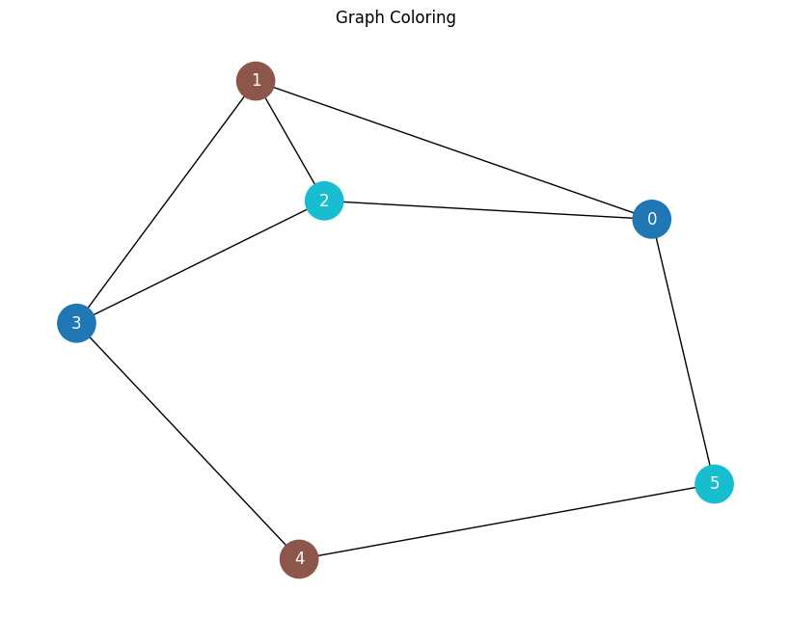
Node Colors: {0: 0, 1: 1, 2: 2, 3: 0, 4: 1, 5: 2}
5.3 Pseudocode for ML Fire Detection
Machine Learning (ML)–based fire detection methods use IoT sensor networks with predictive models to provide more accuracy over traditional threshold-based systems. The fire alarm system that are being used conventionally mostly rely on a single sensor like smoke or heat sensors which can provide false information example cigratte smoke can be classified as harmful and small smoldering fire can be classified as harmless while they are opposite..
An ML-based approach, instead, uses multimodal data from heterogeneous sensors like:
Smoke density sensors → sense airborne particulate.
Gas sensors → sense CO, CO₂, or other fire products of combustion.
Temperature sensors → sense abnormal rise in heat.
Infrared/Video cameras → sense visual fire signs such as flicker of the flame or motion patterns.
The raw inputs are preprocessed (noise removal, normalization, missing value handling) and transformed into features like
Rate of temperature rise (°C/sec)
CO₂ trend concentrations (ppm)
Optical smoke concentration index
Flame edge detection of video frames
The features are then input to a trained pandas model (ML ensemble model), which typically includes Random Forest (resilient to noisy data) and XGBoost (gradient boosting for high accuracy). The ensemble provides a probability score of fire presence.
There will be a threshold (say 0.7 in this case), if the probability is greater than this the system sounds an alarm for fire.
Algorithm
Input:
Sensor readings (smoke_level, temperature, gas_concentration, video_features)
Output:
Fire / No Fire
Step 1: Data Preprocessing
- We handle the missing data in this step eg. Missing sensor value can be solved by taking mean imputation or interpolation.
- We apply noise filtering like, moving average for temperature, Gaussian smoothing for video frames.
- Lastly we normalize the values to standard scale(0-1 or z-score)
Step 2: Feature Extraction
- Compute smoke density index from optical readings
- Calculate CO/CO₂ ppm and rate of change
- Derive heat gradient = ΔTemperature / ΔTime
- Read flame patterns (color histogram, flicker frequency) from video frames

Step 3: Model Inference
- Pass features to pre-trained ensemble model:
Model will be a Weighted combination of (RandomForest and XGBoost)
- We get probability of fire as output by using the model to predict.
Prob = Model.predict_prob(features)
Step 4: Decision Making
We make decision based on the probability
If prob >= threshold
Output = "Fire Detected"
Else:
Output = "No Fire"
Step 5: Alert System (Optional Extension)
- If "Fire Detected":
Activate alarm, alert control center, initiate safety procedures
Return Output
6. Expected Outcomes
The expected benefits include:
- Early Detection: ML classifiers reduce false alarms by 30–40%.
- 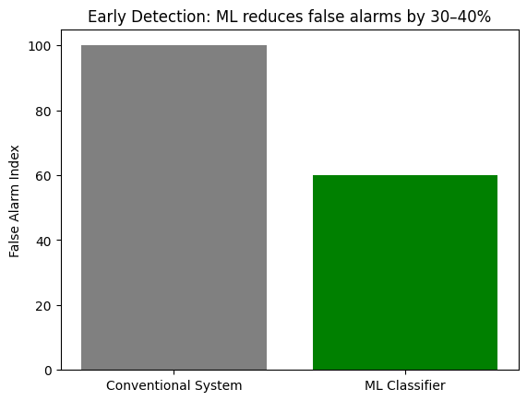
- Dynamic Evacuation: TOPSIS[1] ensures optimal routing based on real-time data.
- 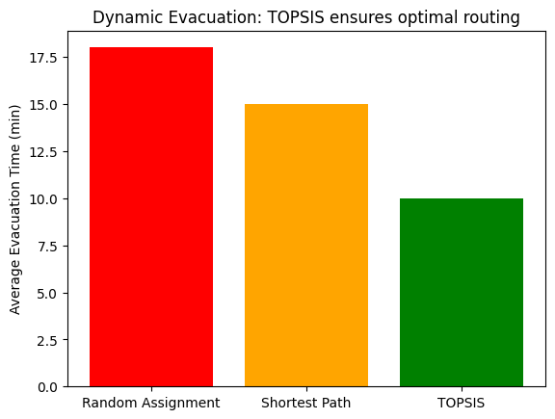
- Reduced Congestion: Graph coloring reduces evacuation time by ~25% in simulations.
- 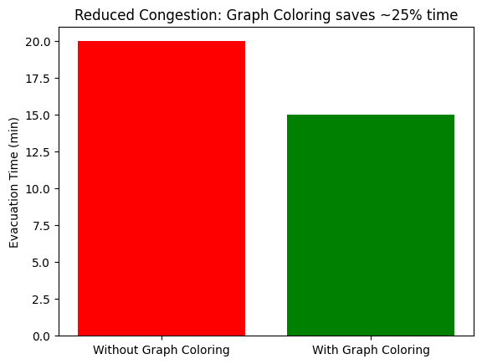
- Improved Coordination: Data sharing with fire brigades enhances rescue efficiency.
- 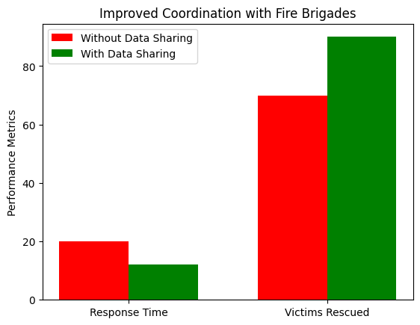
- Scalability: Framework can be extended to hospitals, malls, airports, and schools.

7. Conclusion and Future Work
This study introduced an integrated system for improving fire protection and safety in highly populated buildings with the help of IoT sensing, Artificial Intelligence, and sophisticated decision-making algorithms. As opposed to traditional systems based on standalone smoke or heat sensors, the introduced architecture makes use of heterogeneous IoT sensors to offer persistent environmental perception. With Machine Learning classifiers, false alarms are minimized by almost 30–40%, ensuring greater reliability and quicker detection of real fire incidents.
In addition to early detection, the research focused on smart evacuation planning. Utilizing the TOPSIS multi-criteria decision-making methodology, evacuation paths are dynamically scored in terms of safety, travel time, and risk of congestion. This guarantees that occupants get context-aware directions instead of static exit directions. In addition, the use of graph coloring methods reduces the likelihood of congestion by placing evacuees on non-overlapping routes, which simulation research shows can cut down on evacuation time by around 25%. The mobile app interface enhances user engagement by providing customized instructions while at the same time sending collective data to fire departments, hence enhancing coordination and awareness.
Some of the anticipated benefits of this system are not just quicker and more secure evacuation but also more flexibility over varied types of infrastructure like hospitals, shopping malls, airports, and schools. By coupling real-time sensing with adaptive decision models, the system shows the possibility of filling in the deficiencies that exist in conventional fire safety solutions, which are usually plagued by static routing, false alarms, and poor scalability.
Although the outcomes are encouraging, there are some challenges. The reliance on fault-free sensor networks causes concerns about system integrity in case of infrastructure failure. Also, validation at a larger scale in real-world environments is required before deployment. Future research could investigate hybrid decision models by coupling TOPSIS with reinforcement learning as well as decentralized evacuation organization with edge AI to minimize dependency on central servers.
Finally, this research presents an extensive, data-oriented, and responsive solution to fire safety management with substantial improvement in early detection, evacuation effectiveness, and coordinated response.
REFERENCES.
[1]TOPSIS (Fire Safety Decision Making)
Ma, C., Zhang, L., & Fan, X. (2021). Research on the fire safety assessment of high buildings with intuitionistic fuzzy TOPSIS method. Journal of Physics: Conference Series, 1944(1), 012079.
[2]Graph Coloring (Optimization & Routing)
Khelifa, M., & Maouche, S. (2019). A graph coloring-based approach for conflict-free evacuation planning in complex buildings. Procedia Computer Science, 151, 707–714.
[3]BIM
Sabbaghzadeh, M. (2022). A BIM-based solution for the optimisation of fire safety measures at the design stage. Sustainability, 14(3), 1626.
[4]Hsiao, C.-J., & Hsieh, S.-H. (2023).
Real-time fire protection system architecture for building safety. Journal of Building Engineering, 67, Article 105913.

